

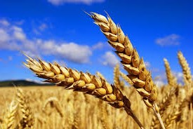

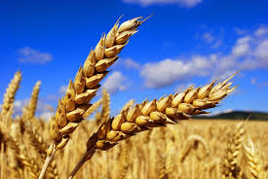

# OBJECTIVES

# 

# AIM OF PROJECT

# Title of Project

To design and develop a smart crop

protection system with the help of Microcontroller.

# 

SMART CROP PROTECTION

1. Develop and deploy a comprehensive crop protection system
2. Establish a real-time alert mechanism to instantly notify farmers of any animal activity

**FROM ANIMALS**

BRANCH: TE E&TC 1

GROUP NO.: 30

# TE E&TC

# 

# BLOCK DIAGRAM

# FLOW CHART

# ABSTRACT

# 

Animals are causing a lot of damage to crops, causing significant financial losses for farmers. To address this issue, we propose an automatic crop protection system leveraging the ESP32 Microcontroller. The integration of PIR and Sound sensors enables the detection of obstacles, providing rapid alerts to farmers.

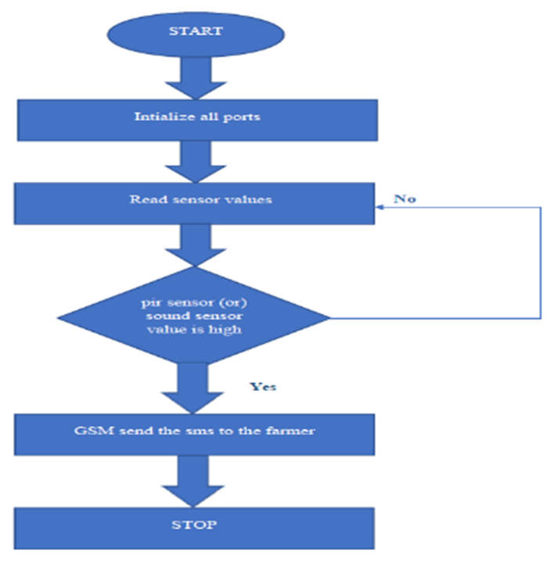

# 



**REGULATOR**

**RECTIFIER**

**GSM**

**MODEM**

**MOTION**

**SENSOR**

**ESP32**

**POWER**

**SUPPLY**

**BUZZER**

**BUCK**

**CONVERTER**

# MOTIVATION

# 

During my recent Diwali vacation back home, I noticed a concerning issue on my own farm. Local animals were causing significant damage to the crops, leaving me worried about the impact on their yield and my livelihood. This personal experience highlighted the widespread problem of crop. protection, which needs effective solutions for farmers.

**LCD**

# FUTURE SCOPE

# 

1. Pest Detection and Management
2. Disease Monitoring and Prevention
3. Weed Identification and Control
4. Optimized Irrigation Management
5. Climate Control in Greenhouses

# APPLICATIONS

1.Integrate advanced wireless sensor networks for real-time data on crop

2.Explore image processing for precise wild animal detection.

conditions.

# METHODOLOGY

# 

Crop protection from animal pests is a critical aspect of agriculture, as pest damage can significantly reduce yields and jeopardize food security. Traditional methods of pest control, such as chemical pesticides and physical barriers, often have detrimental effects on the environment

# LITERATURE REVIEW

1. Identify the goals, limitations and conduct research
2. The design that include the hardware components, such as microcontrollers
3. Develop a prototype of the smart crop protection system
4. Test the prototype under various conditions to ensure that it works as expected
5. Document the design, testing, process, including any modifications made to the design

# CONCLUSION

Ultimately, smart crop protection systems represent a promising avenue for advancing agricultural practices by harnessing technology to improve efficiency, resilience, and sustainability in crop production. As technology continues to evolve and our understanding of agricultural systems deepens, ongoing interdisciplinary research and innovation will play a crucial role.

# REFRENCES

# 

# 

* <https://iarjset.com/papers/smart-crop-protection-using-arduino/>
* <https://www.jetir.org/view?paper=JETIR2203572>

# TEST/RESULTS

# 

**SIMULATION: BREADBOARD IMPLEMENTATION:**

**PROJECT BY-**

1. **ANIKET GUND**
2. **PRAJWAL SHAHANE**
3. **URVI PATIL**

**GUIDE-**

**PROF. R. K. PATIL**

**FOR MORE INFORMATION-**



